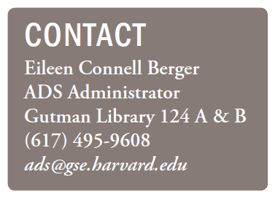
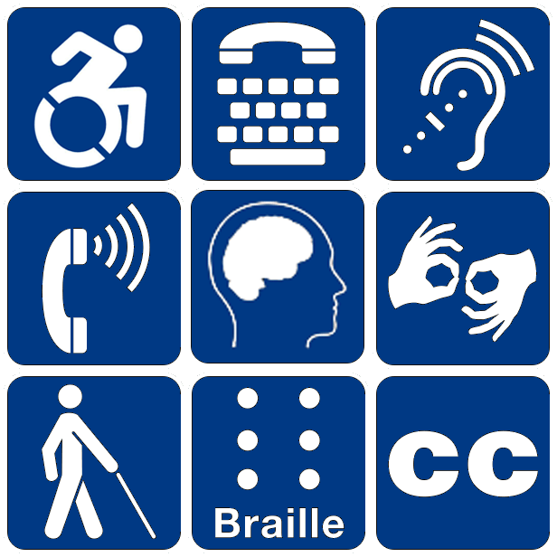
‘“Accessible’ means a person with a disability is afforded the opportunity to acquire the same information, engage in the same interactions, and enjoy the same services as a person without a disability in an equally effective and equally integrated manner, with substantially equivalent ease of use. A person with a disability must be able to obtain the information as fully, equally, and independently as a person without a disability. Although this might not result in identical ease of use compared to that of persons without disabilities, it still must ensure equal opportunity to the educational benefits and opportunities afforded by the technology and equal treatment in the use of such technology.”
-Department of Justice 2014 Youngstown State University Resolution Agreement

ADS ACCESSIBLE TECHNOLOGY SERVICES
We are here to ensure technological assistance to students with the least impact possible on the process of teaching and learning, and we work directly with you and your faculty to provide accessible materials. Access technology is of primary importance to our students with disabilities, and we work with staff, faculty, and IT to go beyond ADAAA compliance in providing access to digital information. We strive to present formats accessible to all users.
Access technology is an ADS accommodation resource dedicated to providing HGSE students with disabilities accessible course materials (including PowerPoints and any projected materials), research materials, and library materials. We also assist with access to classroom activities (including auditory or visual amplification).
ADS offers demonstrations of voice recognition software and any of the other accessible technologies that we use. For students registered with ADS, we offer access to hardware and computer use in partnership with our IT department.


Access Technology
Opening Doors. Opening Minds. Changing Attitudes.
Harvard Graduate School of Education
Access &
Disability
Services
ADS


Access and Disability Technical Services
For approved, registered students with clinical documentation
Contact ADS@gse.harvard.edu or Eileen Berger, Jenny Reuter or
César M. Valencia at 617.495.9608.

The following process outlines roles and responsibilities for Students, ADS Tech, and Faculty.
We appreciate Faculty and Student collaboration to provide access for course participation of ADS Students eligible for access tech services.
1. E-text Conversion Process (at least 2 weeks) for Books, iPacs, e-Research links
2. PowerPoint and other lecture-presented materials (at least 2 weeks)
3. Captioning Course Videos/Films
4. Note-Taking
5. Transcription Services (at least 2 weeks)
6. Software/Hardware Installation and Training

